


Macroeconomic Modelling for Energy Investments in Vietnam
Report on Macroeconomic Impact Assessment
Katja Heinisch, Ulrike Lehr, Christian Lutz, Huyen Nguyen, Christoph Schult

Imprint
Contact
Dr Katja Heinisch
Tel +49 345 77 53 836
E-mail: katja.heinisch@iwh-halle.de
Authors
Katja Heinischª
Ulrike Lehr^{b}
Christian Lutz^{b}
Huyen Nguyen^{a,c}
Christoph Schultª
ª Halle Institute for Economic Research (IWH)
^{b} GWS – Gesellschaft für Wirtschaftliche Strukturforschung (GWS) mbH
^{c} King’s College London
Issuer
Halle Institute for Economic Research (IWH) – Member of the Leibniz Association

Executive Board
Professor Reint E. Gropp, PhD
Professor Dr Oliver Holtemöller
Professor Michael Koetter, PhD
Dr Tankred Schuhmann

Address
Kleine Maerkerstrasse 8
D-06108 Halle (Saale), Germany
Postal Address
P.O. Box 11 03 61
D-06017 Halle (Saale), Germany
Tel +49 345 7753 60

www.iwh-halle.de
All rights reserved.

Macroeconomic Modelling for Energy Investments in Vietnam
Report on Macroeconomic Impact Assessment
Katja Heinisch, Ulrike Lehr, Christian Lutz, Huyen Nguyen, Christoph Schult
Halle (Saale), 31.07.2026

Table of Contents
Table of Contents 4
List of Figures 5
List of Tables 5
Abbreviations 6
Executive Summary 7
1 Introduction 10
1.1 The implementation challenge 10
1.2 Policy questions 11
1.3 Purpose of this report 11
2 Policy Instruments Assessed 13
2.1 Energy efficiency 13
2.2 Green finance architecture 16
2.3 Carbon pricing and the Net-Zero pathway 19
3 Cross-Cutting Findings 21
3.1 Energy efficiency reduces the overall cost of the transition 22
3.2 Financing conditions determine the pace of investment 22
3.3 Carbon pricing is most effective within an integrated policy framework 22
3.4 Structural adjustment is concentrated in fossil-energy activities 22
3.5 Carbon pricing has important fiscal implications 23
3.6 Policy instruments are complementary rather than substitutable 23
4 Policy Recommendations 24
5 Conclusion 25
6 Interpreting the Results: Scope and Limitations 26
7 Annex: Methodology Summary 29
References 30

List of Figures
Figure 1: Impact on GD of Energy Efficiency Efficicncy Measures 13
Figure 2: Energy-intensity deviation of Energy Efficiency Directive 10, EE Directive 10 no Battery Storage Systems (BESS) and EE PDP 8 and Photovoltaic and no BESS to PDP8 Baseline. 14
Figure 3: GDP growth under GF_A, GF_B, and GF_C financing architectures vs. the PDP8 Baseline. 16
Figure 4: Weighted average cost of capital (WACC) for renewable investment under GF_A, GF_B, and GF_C. 16
Figure 5: Weighted average cost of capital (WACC) and GDP effect under GF A, GF B, and GF C for Net Zero. 17
Figure 7: Five-year average deviations in ETS revenue as a share of GDP from the PDP8 baseline. 20
Figure 6: GDP level deviation from the PDP8 Baseline. 20
Figure 8: Energy-intensity deviation of NZ and constrained decomposition variants from the PDP8 Baseline. 21

List of Tables
Table 1: Green finance instruments 16

Abbreviations
BESS Battery Energy Storage System
CO₂ Carbon Dioxide
COP26 26th United Nations Climate Change Conference of the Parties
DGE Dynamic General Equilibrium
DGE-METRIC Dynamic General Equilibrium for Macroeconomic Energy Transition Incorporating Carbon Markets
EE Energy Efficiency
ETS Emissions Trading System
FDI Foreign Direct Investment
GDP Gross Domestic Product
GHG Greenhouse Gas
MDB Multilateral Development Bank
MOIT Ministry of Industry and Trade
NDC Nationally Determined Contribution
NZ Net Zero
ODA Official Development Assistance
PDP8 Revised Power Development Plan VIII
PM Prime Minister
PV Photovoltaic
WACC Weighted Average Cost of Capital
WACF Weighted Average Cost of Finance

Executive Summary
Vietnam's commitment to achieve net-zero greenhouse gas emissions by 2050 requires an unprecedented transformation of its energy system. The revised Power Development Plan VIII (PDP8) provides the strategic framework for this transition, but its successful implementation depends not only on expanding renewable energy capacity but also on mobilising affordable finance, improving energy efficiency, and establishing effective carbon pricing mechanisms. These policy choices will shape not only Vietnam's emissions trajectory but also its long-term economic growth, investment, and competitiveness.
This report assesses the macroeconomic implications of three key policy levers using DGE-METRIC (Dynamic General Equilibrium for Macroeconomic Energy Transition Incorporating Carbon markets), a dynamic general equilibrium model calibrated to the Vietnamese economy with 5 sectors. The analysis compares alternative energy-efficiency pathways, green-finance architectures, and carbon-pricing scenarios over the period 2026–2050 to evaluate how different policy packages affect economic performance and the cost of the energy transition.
The analysis leads to five principal findings:
- Energy efficiency delivers economic gains while supporting the energy transition.
Accelerating energy-efficiency improvements increases economic output with only modest additional investment requirements. Both PDP8-consistent and more ambitious (PM Directive 10/CT-TTg) efficiency targets raise GDP levels throughout the 2026–2050 horizon, with only a small near-term investment-consumption trade-off. Scaling ambition from PDP8 to Directive-10-equivalent targets increases GDP by one percent for an incremental cost of USD 100–150 million per year.
- Affordable green finance substantially lowers the cost of the transition.
Lower financing costs stimulate renewable investment, increase long-term economic growth, and reduce the overall cost of implementing Vietnam's energy transition. Shifting from market-led to public-led (concessional) green finance reduces annual financing costs by approximately USD 3 billion, compounding into a persistent GDP growth premium that builds through the 2030s as lower-cost capital accumulates.
- Carbon pricing is most effective when combined with complementary policies.
A binding emissions cap accelerates decarbonisation relative to the PDP8 baseline but imposes adjustment costs on the economy. These costs are significantly reduced when firms can respond through fuel switching, technological improvements, and stronger energy efficiency; the cost rises substantially under a “worst case” of limited technological learning. Carbon pricing should therefore be implemented as part of a broader policy package rather than as a standalone instrument.
- Policy instruments reinforce one another.
The strongest macroeconomic outcomes are achieved when energy efficiency, affordable finance, and carbon pricing are implemented together. The analysis demonstrates that these policies are complementary rather than substitutable: improved financing conditions increase the effectiveness of climate policy, while energy-efficiency improvements reduce the economic cost of achieving emissions targets.
- Early action delivers the greatest economic benefits.
The largest gains arise during the period of rapid investment before 2035. Mobilising concessional finance, accelerating energy-efficiency programmes, and establishing credible carbon-market institutions early in the transition can substantially reduce long-term adjustment costs while supporting sustainable economic growth.
Overall, the results suggest that Vietnam's energy transition should not be viewed solely as an environmental challenge but as an economic transformation requiring coordinated investment, financial-sector development, and complementary policy design. Well-designed policy packages can substantially reduce the macroeconomic costs of decarbonisation while supporting long-term growth, competitiveness, and energy security. The findings provide quantitative evidence to support policymakers and development partners in prioritising investments and policy reforms that enable a cost-effective and economically resilient transition to net-zero emissions.

Introduction
Vietnam is one of Southeast Asia's fastest-growing economies, with electricity demand having approximately doubled every decade over the past two decades. This rapid growth has been supported by coal-fired power generation, making the decarbonisation of the energy sector one of the country's most significant economic and policy challenges. To address this challenge, Vietnam has adopted a set of ambitious climate and energy commitments:
- Net-zero greenhouse gas emissions by 2050, announced at COP26 and reaffirmed in its updated Nationally Determined Contribution (NDC);
- A 60% share of renewable electricity by 2030, as outlined in the revised Power Development Plan VIII (PDP8; Decision No. 500/QD-TTg, 2023);
- No new coal-fired power capacity after 2030, a central pillar of the revised PDP8.
These commitments compress an energy transition that would normally unfold over several decades into little more than a decade. Throughout this report, the revised PDP8 serves as the Baseline scenario (reference), representing the development path under currently announced energy and climate policies. The baseline assumes a rapid expansion of renewable electricity generation, storage technologies, and transmission infrastructure, together with a gradual phase-down of coal-fired power and continued economic growth of approximately 10 percent per year until 2030 and 7.5 percent between 2030 and 2050, recognising that its successful implementation depends on investment mobilisation, institutional capacity, and policy execution.

The implementation challenge
Investment scale. Achieving the objectives of PDP8 requires an unprecedented mobilisation of capital. The IWH Investment Needs Assessment (2025) estimates cumulative investment requirements of approximately USD 1 trillion between 2026 and 2050 excluding maintenance expenditures, covering renewable electricity generation, transmission and grid reinforcement, energy-efficiency improvements, and climate-adaptation measures. The central policy question is therefore not whether Vietnam can ultimately afford the transition, but whether investment can be mobilised at sufficient scale, at sufficiently low cost, and within the implementation timeline required to achieve the country's climate and energy objectives.
The financing gap. Financing conditions represent one of the principal constraints to this transition. The accompanying IWH Financial Assessment (2025) identifies a significant financing gap during the investment-intensive period before 2035, driven by large upfront infrastructure costs, comparatively high commercial borrowing costs for private energy projects, a limited domestic institutional investor base, and uncertainty regarding future carbon-market revenues. Green finance instruments—including concessional lending, blended finance, green bonds, and development finance—are intended to narrow this gap by lowering the effective cost of capital and encouraging private investment.
Carbon market development. At the same time, Viet Nam is implementing a pilot domestic emissions trading system under Decree No. 06/2022/NĐ-CP, as amended by Decree No. 119/2025/NĐ-CP, with the domestic carbon exchange governed by Decree No. 29/2026/NĐ-C. Together, financing conditions and carbon pricing will play a central role in determining both the pace and the macroeconomic cost of the energy transition.

Policy questions
Against this background, this report evaluates three policy areas that are central to Vietnam's energy transition. Each addresses a different constraint to achieving the country's climate objectives while sustaining long-term economic growth.
- Energy efficiency. How much can accelerated improvements in energy efficiency reduce energy demand, lower investment requirements, and support economic growth? The analysis examines alternative efficiency pathways to quantify their macroeconomic implications and their contribution to reducing the overall cost of the energy transition.
- Green finance. To what extent can improved financing conditions accelerate investment in renewable energy? The analysis evaluates how lower financing costs—through concessional lending, blended finance, green bonds, and other financial instruments—affect investment, economic growth, and the affordability of Vietnam's energy transition.
- Carbon pricing. How can an emissions trading system (ETS) support Vietnam's net-zero commitment while limiting macroeconomic adjustment costs? The analysis examines alternative carbon-revenue recycling pathways and assesses how complementary policies influence both emissions reductions and economic performance.
Taken together, these policy instruments address the three principal dimensions of the energy transition: reducing energy demand, mobilising investment, and creating incentives for decarbonisation. While each policy can influence macroeconomic outcomes individually, their greatest impact is expected when implemented as part of a coordinated policy package.

Purpose of this report
This report evaluates the macroeconomic implications of alternative policy pathways using DGE-METRIC (Dynamic General Equilibrium for Macroeconomic Energy Transition Incorporating Carbon markets), a dynamic general equilibrium model calibrated to the Vietnamese economy. The model captures interactions between households, firms, government, international trade, and the energy sector, allowing alternative policy scenarios to be evaluated within a consistent macroeconomic framework. Rather than forecasting Vietnam's future economy, the model compares internally consistent policy scenarios to identify the economic consequences of different policy choices and the mechanisms through which they affect long-term development.
Rather than forecasting Vietnam's future economy, the model compares internally consistent policy scenarios to examine how alternative assumptions regarding energy efficiency, financing conditions, and carbon pricing influence economic growth, investment, energy demand, and emissions over the period 2026–2050. The analysis is intended to inform policy design by identifying the mechanisms through which different policy instruments—and combinations of instruments—affect both the pace and the cost of Vietnam's transition to net-zero emissions.
The remainder of this report is organised as follows. Section 2 presents the macroeconomic assessment of the three policy instruments, covering energy efficiency, green finance, and carbon pricing. Section 3 synthesises the cross-cutting findings and discusses their policy implications. Section 4 presents recommendations for policymakers and development partners, while Section 5 summarises the principal modelling assumptions and limitations. A concise description of the modelling framework is provided in the Annex, with additional methodological details available in the accompanying technical report.

Policy Instruments Assessed
This section evaluates three complementary policy instruments that address different dimensions of Vietnam's energy transition. While each instrument can influence macroeconomic outcomes individually, the greatest benefits arise when they are implemented as part of a coherent policy package. The analysis therefore examines the effects of energy-efficiency improvements, alternative green-finance architectures, and carbon pricing under a common modelling framework, allowing their individual and combined macroeconomic impacts to be assessed.

Energy efficiency
Policy context. Improving energy efficiency is widely recognised as one of the most cost-effective measures for reducing future energy demand while supporting economic growth. Vietnam's revised PDP8 already incorporates significant efficiency improvements across industry and services, while Prime Minister Directive 10/CT-TTg calls for a more ambitious acceleration of energy-saving measures. A key policy question is whether increasing energy-efficiency ambition generates sufficient macroeconomic benefits to justify the additional investment required. Battery energy storage systems (BESS) are also assessed as part of the analysis to distinguish their contribution to system performance from their aggregate macroeconomic effects.
Energy Efficiency Directive 10. Directive No. 10/CT-TTg places electricity saving and demand-side management at the centre of Viet Nam's response to rapid demand growth and emerging risks to security of supply. It calls for stronger electricity savings, lower peak demand, more efficient equipment and production processes, and greater use of self-consumption rooftop solar combined, where appropriate, with battery energy storage. The EE Directive 10 scenario translates this policy direction into an economy-wide pathway and is evaluated against the more moderate revised PDP 8 reference. The Directive 10 pathway assumes sector-specific energy savings by 2030 of approximately 7.4% in industry and 5.1% in services, supported by combined investment of about USD 361 million per year, equivalent to approximately 0.076% of GDP. These values are expert-calibrated modelling assumptions used to represent the Directive's higher ambition; they are not quantitative targets stated verbatim in the Directive. Both pathways are assessed under the same emissions trajectory, maintained through the emissions trading system, so that differences in outcomes capture the macroeconomic effects of stronger energy efficiency rather than differences in emissions. Additional `NoBESS` counterfactuals remove the storage-specific channels while retaining the energy-efficiency assumptions, thereby identifying the contribution of BESS to aggregate economic performance.
Results. The simulations produce four principal findings.
- Higher energy efficiency improves economic performance. Efficiency scenarios increase GDP relative to the PDP8 baseline; Directive-10 ambition delivers roughly 0.80 percentage points higher GDP level than PDP~8 across 2026–2050, for an incremental investment cost of less than 0.1% of GDP (Figure 1).
- The additional investment requirement is modest. Achieving higher efficiency requires only a limited increase in investment expenditure, while the temporary reduction in consumption is small and largely offset by stronger long-term economic growth and lower energy costs in the future.
- Energy demand declines, but emissions are identical. Under a binding carbon constraint, lower energy intensity reduces energy use but does not necessarily translate into lower greenhouse gas emissions, as the electricity mix remains determined by the baseline scenario. At the same time lower energy demand translates into lower emission prices which therefore reduces cost pressure for energy intensive industries and stabilizes cost of living.
- Battery energy storage (BESS) has limited macroeconomic effects. Removing battery storage has only a negligible impact on aggregate GDP (~0 pp by 2050), indicating that its primary value lies in improving power-system reliability and enabling renewable integration rather than directly increasing economy-wide output.
- Rooftop solar (RTS) is the main driver of the positive GDP effects. Our scenario analysis shows that the expansion of RTS accounts for most of the projected increase in GDP. Accelerating its deployment therefore appears to be one of the most promising measures for reducing demand for centrally supplied electricity, easing pressure on the power system, and supporting grid stability during the energy transition.

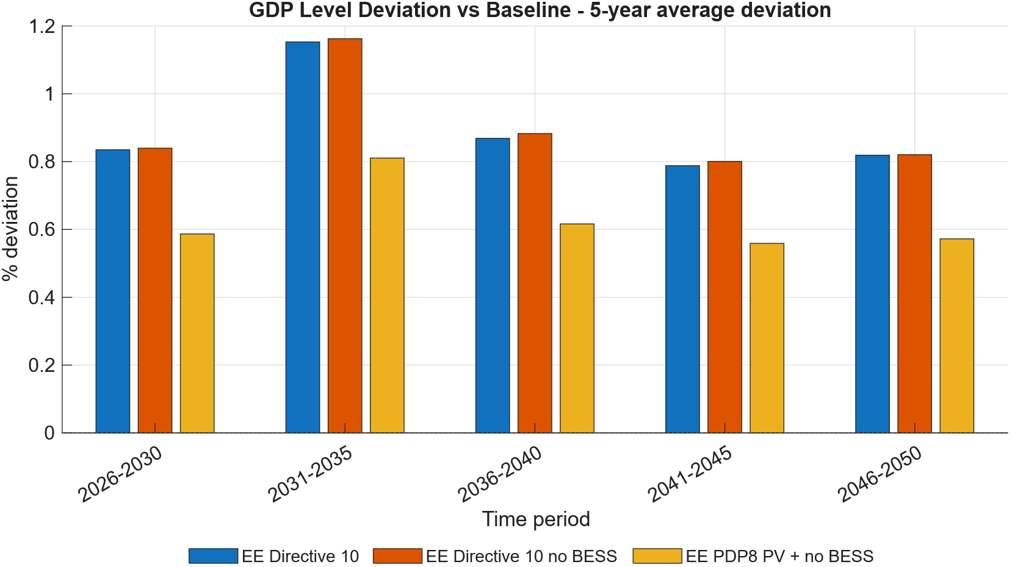
Figure 1: Impact on GD of Energy Efficiency Efficicncy Measures

Note: Values are percent deviations of GDP level from the PDP8 Baseline path, 2026–2050. Directive 10, EE Directive 10 no Battery Storage Systems (BESS) and Photovoltaic and no BESS to PDP8 Baseline for an incremental investment cost of USD 100–150 million/year.
Source: Authors’ calculations using the DGE-METRIC

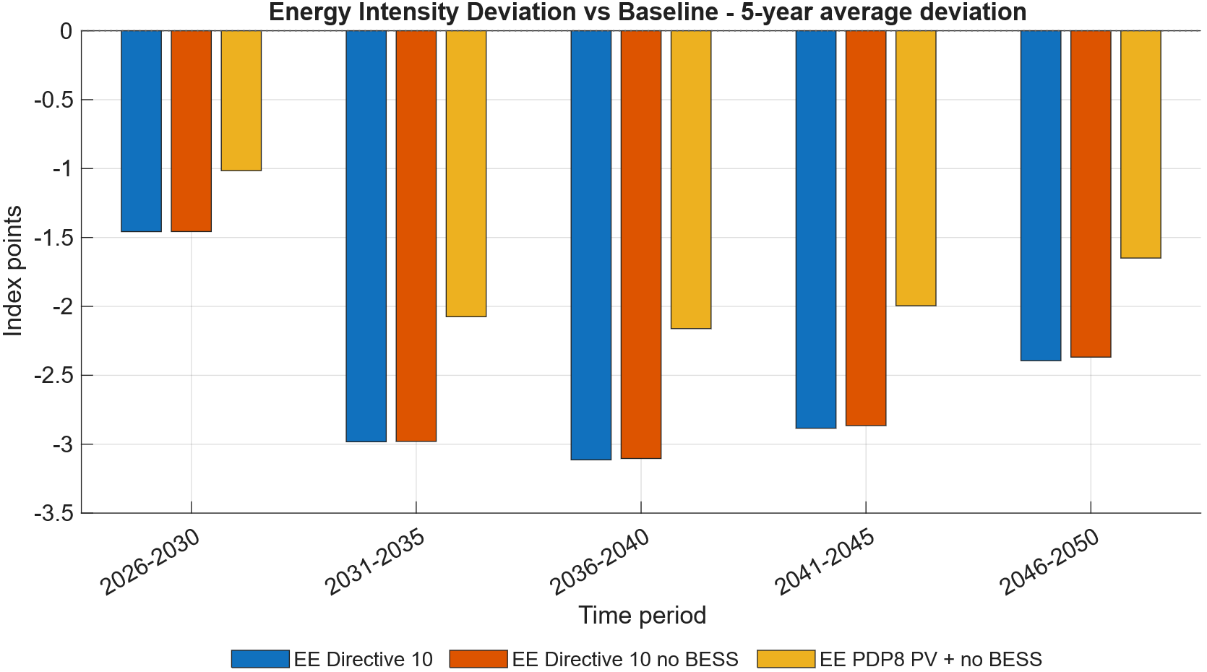
Figure 2: Energy-intensity deviation of Energy Efficiency Directive 10, EE Directive 10 no Battery Storage Systems (BESS) and EE PDP 8 and Photovoltaic and no BESS to PDP8 Baseline.
Note: Values are index-point deviations from the Baseline energy-intensity index (2026=100). Directive 10 delivers a roughly 3.0 pp lower energy intensity index than PDP8 by 2030, falling to about 2.5 pp by 2050.
Source: Authors’ calculations using the DGE-METRIC model.

Note: Index (2026 = 100). All four EE variants track the same emissions path — efficiency reduces energy intensity but does not, by itself, bend the emissions path absent a binding carbon constraint.
Source: Authors’ calculations using the DGE-METRIC.

Policy implication. The results suggest that energy efficiency should be regarded as a low-cost growth policy as well as an energy policy. Accelerating efficiency improvements delivers sustained economic benefits while reducing future energy demand and investment requirements. However, energy efficiency alone cannot achieve Vietnam's emissions objectives. To maximise both economic and environmental benefits, efficiency policies should therefore be implemented alongside carbon pricing and continued investment in low-carbon electricity generation.

Green finance architecture
Policy context. Mobilising investment at the scale required by the revised PDP8 will depend not only on the availability of capital but also on its cost. Renewable energy projects are characterised by high upfront investment costs and relatively low operating costs, making financing conditions a key determinant of project viability. Reducing the cost of capital through concessional finance, blended finance, green bonds, and other financial instruments can therefore accelerate renewable energy deployment while lowering the overall economic cost of the transition.
Scenarios. Three financing architectures are compared. The balanced GF A architecture combines ODA/MDB finance, blended finance, and green bonds. It allocates renewable investment across 19.0% public capital, 14.0% FDI, and 67.0% domestic private/household capital; with modeled public and FDI capital costs of 6.43% and 6.36%, respectively. The market-led GF B architecture allocates 9.6% to public capital, 12.4% to FDI, and 78.0% to domestic private/household capital. Its modeled public and FDI capital costs are 7.37% and 6.90%. The public-led GF C architecture, dominated by concessional and ODA finance, raises the public share to 36.5% and the FDI share to 19.0%, leaving 44.5% for domestic private/household capital. Its modeled public and FDI capital costs are 5.07% and 6.00%.
Table 1: Green finance instruments
Green finance instrument | Expected primary macroeconomic effect
Concessional loans | Lower financing costs and increase investment
Blended finance | Mobilise private capital and reduce project risk
Green bonds | Expand long-term financing for infrastructure
Development-bank facilities | Reduce investment constraints during the transition
Source: Own depiction.
Results. The simulations produce four principal findings:
- Lower financing costs stimulate investment. Reducing the cost of capital increases investment in renewable energy and accelerates capital accumulation. The public-led (GF_C) vs. market-led (GF_B) comparison with a roughly 1.5 percentage-point WACF spread translates into approximately 1 percentage point higher GDP in 2050.
- Green finance supports stronger economic growth. While the GDP effect can be slightly negative in the very short run (higher investment temporarily displaces consumption), improved financing conditions increase long-term GDP by reducing investment costs and through lower WACF lower energy prices.
- Macroeconomic benefits increase with the scale of financial support. More ambitious financing arrangements generate progressively larger economic gains, highlighting the importance of mobilising concessional and blended finance at scale. When the same finance scenarios are run against the NZ baseline, investment requirements are larger and the cost of capital more binding, so a given WACF reduction has a larger absolute GDP effect than under PDP8 alone (Figure 5).
- Green finance complements other policy instruments. Lower financing costs enhance the effectiveness of both energy-efficiency policies and carbon pricing by reducing the economic cost of low-carbon investment and facilitating the transition to cleaner technologies.
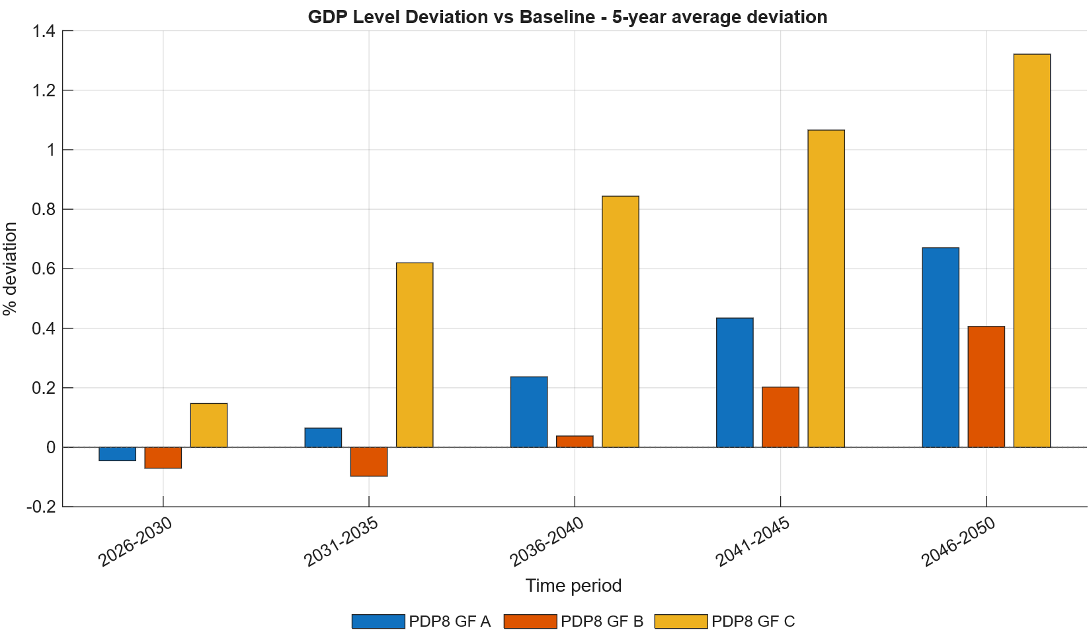
Figure 3: GDP growth under GF_A, GF_B, and GF_C financing architectures vs. the PDP8 Baseline.
Note: Annual GDP growth rates, 2026–2050. Cheaper capital (GF_C, public-led) delivers a measurable growth premium over market-led finance (GF_B), largest after 2035.
Source: Authors’ calculations using the DGE-METRIC model.
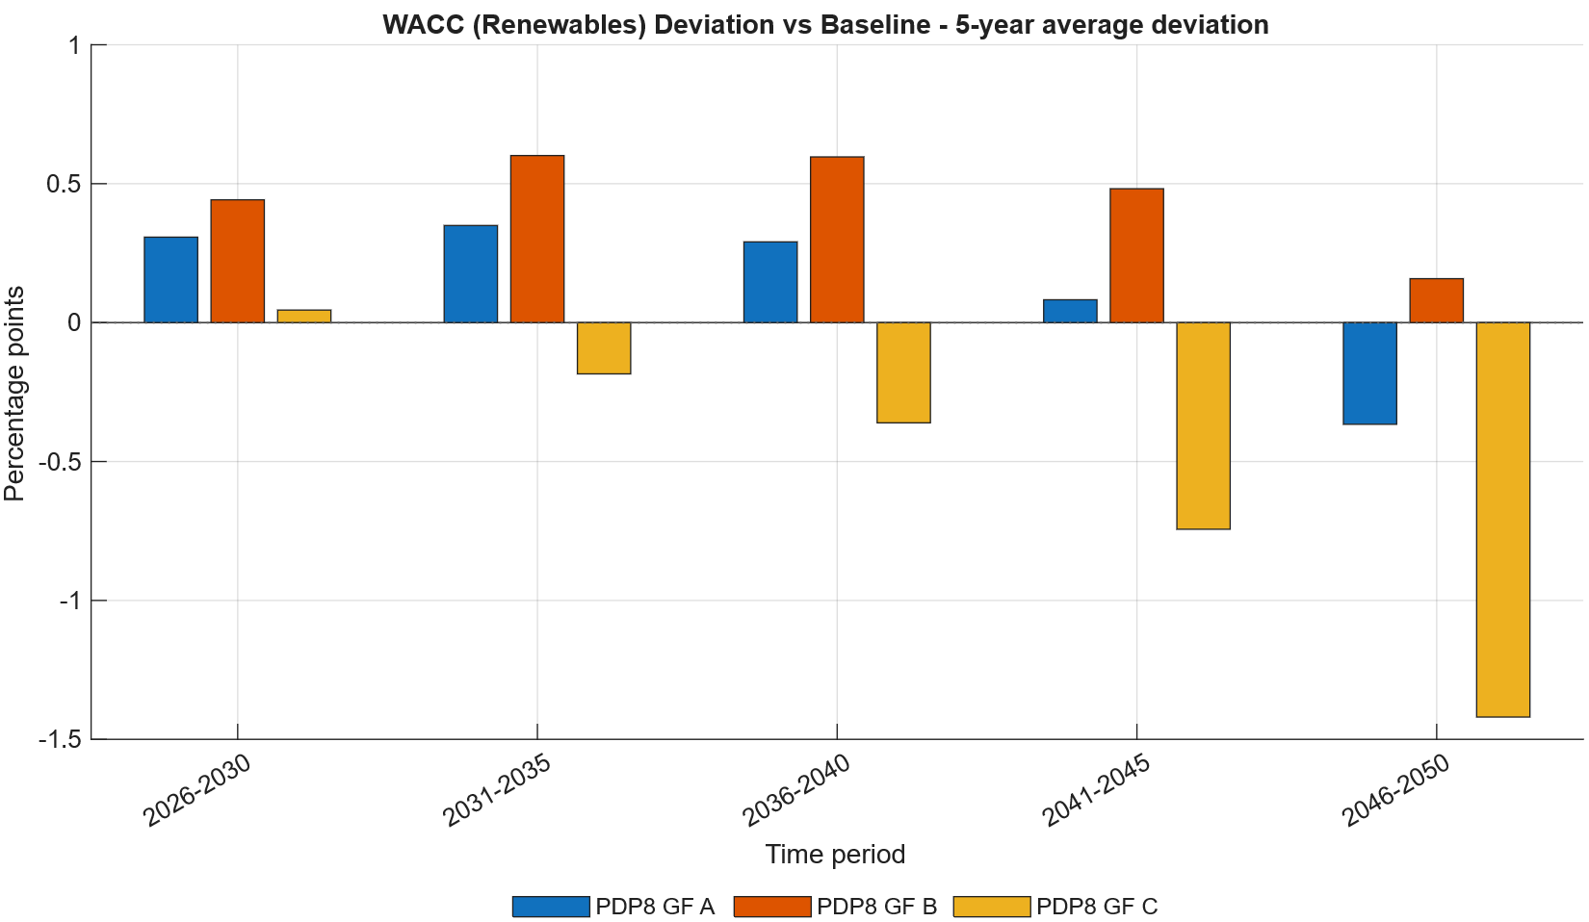
Figure 4: Weighted average cost of capital (WACC) for renewable investment under GF_A, GF_B, and GF_C.
Note: Effective financing cost for renewable energy investment, in percent. The roughly 1.5 percentage-point WACF spread between GF C and GF B translates directly into a lower effective WACC for renewable investment.
Source: Authors’ calculations using the DGE-METRIC model.
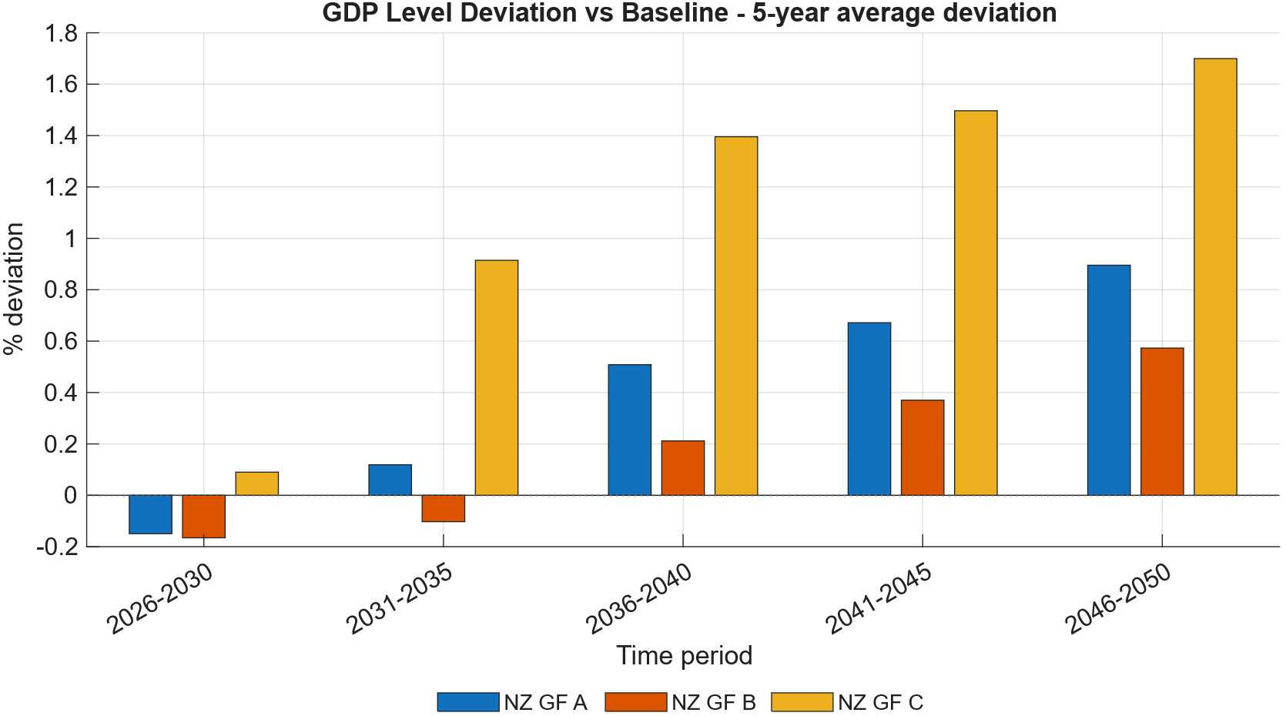
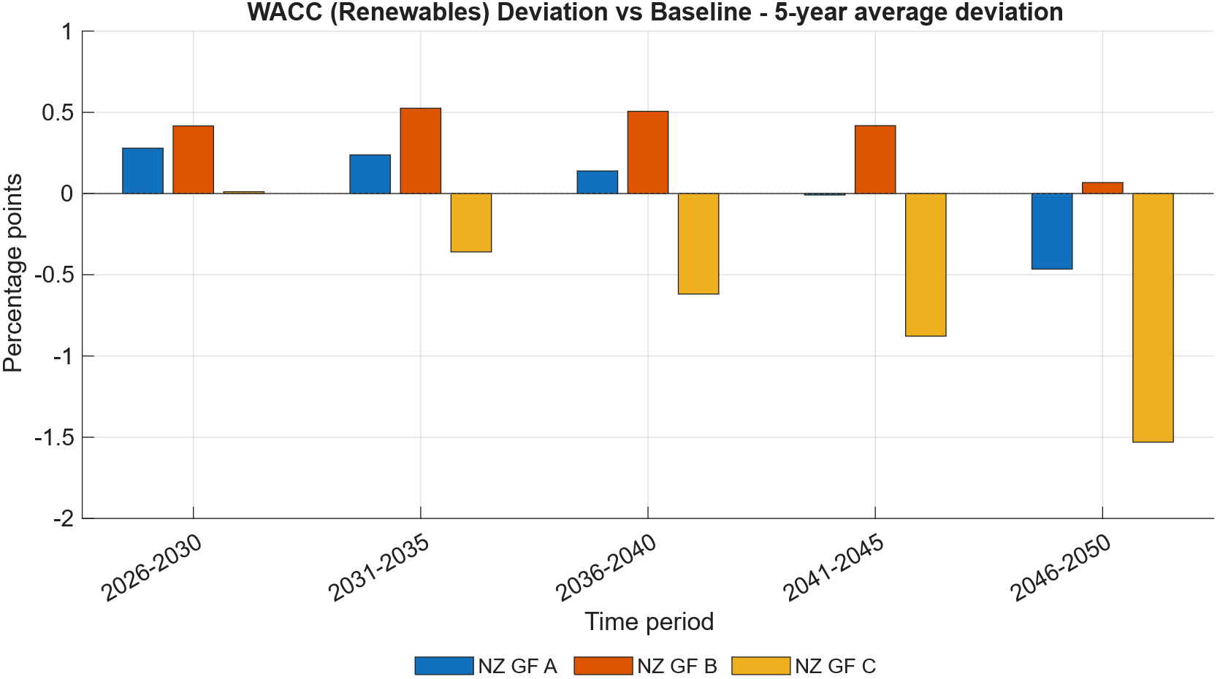
Figure 5: Weighted average cost of capital (WACC) and GDP effect under GF A, GF B, and GF C for Net Zero.
Note: Effective financing cost and GDP effects in percent relative to Net Zero.
Source: Authors’ calculations using the DGE-METRIC model.

Policy implications. The results suggest that green finance should be viewed as an economic policy rather than solely a financial instrument. By lowering the effective cost of capital, concessional finance and blended-finance mechanisms can accelerate renewable investment while supporting economic growth and reducing transition costs. Expanding access to affordable finance should therefore be a central component of Vietnam's energy-transition strategy, alongside continued improvements in energy efficiency and the gradual introduction of carbon pricing.

Carbon pricing and the Net-Zero pathway
Policy context. Vietnam’s current policy trajectory is not sufficient to achieve net-zero emissions. Closing this gap will require emissions covered by the domestic emissions trading system (ETS) to decline more rapidly. A tighter emissions cap and the resulting increase in carbon prices would strengthen incentives for firms to reduce fossil-fuel use, improve energy efficiency, and adopt low-carbon technologies. However, faster emissions reductions may also raise production and investment costs, placing downward pressure on economic growth, particularly when affordable low-carbon alternatives and financing are limited.
The macroeconomic effects of a stricter ETS therefore depend critically on complementary policies and the use of ETS revenues. Recycling these revenues through subsidies for renewable-energy investment, direct transfers to households and firms, or other targeted support can offset part of the adverse effects on GDP growth. Additional measures, such as the GF C green-finance policy, energy-efficiency improvements, and redistributive revenue recycling, can further accelerate technological adjustment and help overcome the negative growth effects associated with a more stringent emissions pathway. Designing the ETS together with these complementary measures is therefore essential for reconciling Vietnam’s net-zero commitment with economic growth and competitiveness.
Scenarios. The analysis evaluates a set of carbon-pricing scenarios based on an economy-wide emissions cap consistent with Vietnam's long-term net-zero objective (Net-Zero (NZ) scenario). The scenarios compare alternative carbon-price pathways in combination with different recycling schemes of the ETS revenues. In addition to the NZ scenario, which does not redistribute the ETS revenues, we simulate an NZ scenario with ETS revenues recycled as subsidies to reduce the cost of capital for non-fossil capital (NZ subsidy) and as transfer to citizens as a climate dividend (Net Zero direct subsidy). Further, we simulate a scenario reaching net-zero but also implementing public led green finance instruments (GF C) and energy efficiency measures as foreseen by Directive 10 in combination with subsidies for investments in renewables (Net Zero + GF C + EE + subsidies).
Results. The simulations produce four principal findings:
- Carbon pricing can generate remarkable revenues. The net zero emission compatible path will lead to cumulative ETS revenues of roughly 340 billion USD or roughly 30 percent of total investment needs to accomplish the revised PDP 8 pathway (Figure 6).
- Carbon pricing entails short-term adjustment costs. Higher carbon prices increase production costs in emissions-intensive sectors, leading to modest but persistent reductions in GDP and consumption during the transition period without recycling of the higher ETS revenues (Figure 7) and the implementation of additional energy efficiency measures and green finance scenarios (Figure 8).
- Recycling ETS revenues into investment subsidies that reduce the capital cost of renewable energy is preferable to distributing them as climate dividends, as it directly accelerates renewable deployment, lowers transition costs, and generates stronger long-term economic benefits (Figure 8).
- A predictable emissions-reduction pathway toward net zero—combined with publicly supported green finance, stronger energy-efficiency measures, and the productive recycling of ETS revenues—can raise GDP growth above the revised PDP8 baseline and more than offset the adverse economic effects of tighter emissions constraints.

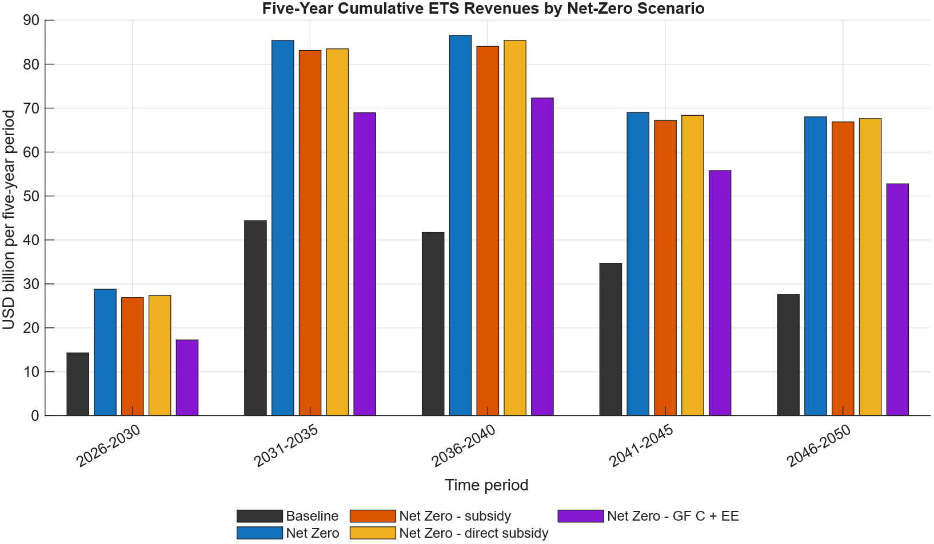
Figure 6: Five-year cumulative emissions trading system revenues under the PDP8 baseline and net-zero scenario.
Note: Values are index-point deviations from the Baseline energy-intensity index (2026=100). The ETS carbon price accelerates efficiency investment beyond what PDP8 alone induces, amplifying the energy intensity decline relative to the EE-only scenarios in §3.1.
Source: Authors’ calculations using the DGE-METRIC model.

.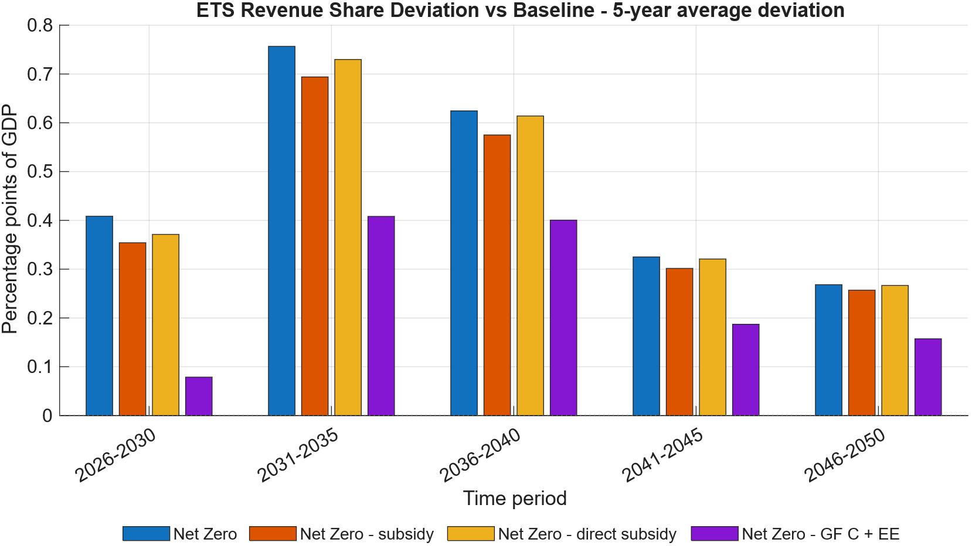
Figure 7: Five-year average deviations in ETS revenue as a share of GDP from the PDP8 baseline.
Note: Index (2026 = 100). The binding cap forces accelerated emissions decline; the more adjustment channels are held fixed (NZ_constInt, then NZ_constEEInt), the higher the carbon price needed to hit the same emissions path.
Source: Authors’ calculations using the DGE-METRIC model.
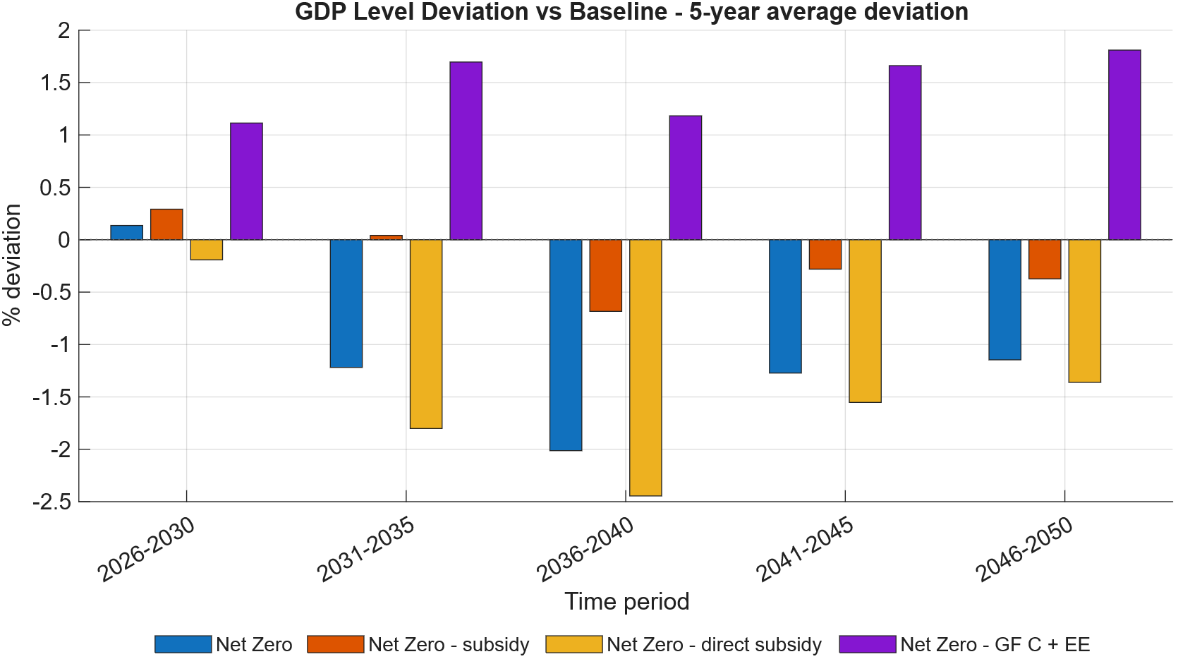
Figure 8: GDP level deviation from the PDP8 Baseline.
Note: Values are percent deviations of GDP level from the PDP8 Baseline path, 2026–2050. The decomposition variants show how much of the net-zero transition’s GDP cost is attributable to forgoing fuel-switching and efficiency channels.
Source: Authors’ calculations using the DGE-METRIC model.

Policy implications. The results indicate that carbon pricing should be implemented as part of a broader policy package rather than as a standalone instrument. An effective ETS can provide a transparent and technology-neutral incentive for emissions reductions, but its economic costs are significantly lower when firms have access to affordable finance and opportunities to improve energy efficiency. Coordinating carbon pricing with complementary investment and financing policies can therefore accelerate decarbonisation while limiting macroeconomic adjustment costs and supporting Vietnam's long-term competitiveness.

Cross-Cutting Findings
The scenario analysis demonstrates that Vietnam's energy transition should be understood as a coordinated economic transformation rather than a sequence of independent policy interventions. Energy efficiency, green finance, and carbon pricing influence different dimensions of the transition, yet their impacts are closely interconnected. Evaluating these policy instruments within a common macroeconomic framework reveals six overarching findings that are relevant for policy design.

Energy efficiency reduces the overall cost of the transition
Across all scenarios, accelerated improvements in energy efficiency consistently generate positive macroeconomic outcomes. Higher efficiency reduces energy demand, lowers production costs, and supports long-term economic growth while requiring only modest additional investment. By reducing the scale of future electricity demand, energy efficiency also decreases the investment required in generation and network infrastructure, thereby lowering the overall cost of the energy transition.
However, energy efficiency alone is insufficient to achieve Vietnam's climate objectives. In the absence of a binding emissions constraint, lower energy demand does not automatically translate into lower greenhouse gas emissions. Its greatest contribution therefore lies in reducing the economic cost of decarbonisation when combined with complementary climate policies.

Financing conditions determine the pace of investment
The analysis confirms that financing conditions are a major determinant of transition outcomes. Because renewable energy technologies are highly capital intensive, reducing the cost of capital stimulates earlier investment, accelerates technology deployment, and improves long-term economic performance.
The simulations indicate that concessional finance, blended finance, and other mechanisms that lower financing costs generate benefits extending well beyond the energy sector. By reducing investment costs throughout the transition period, green finance increases economic resilience while improving the affordability of achieving Vietnam's energy and climate objectives.

Carbon pricing is most effective within an integrated policy framework
Carbon pricing provides an effective market-based incentive for emissions reductions but also creates adjustment costs for emissions-intensive sectors. The scenario decomposition demonstrates that these costs depend critically on the availability of complementary mitigation options.
Where firms can improve energy efficiency and substitute towards lower-carbon technologies, the carbon price required to achieve a given emissions pathway is substantially lower. Conversely, constraining these adjustment channels increases both the required carbon price and the associated GDP losses. The analysis therefore shows that energy efficiency and technological flexibility are not optional complements to carbon pricing but essential mechanisms for reducing the economic cost of decarbonisation.

Structural adjustment is concentrated in fossil-energy activities
The transition to net-zero emissions involves significant structural change across the economy, but these adjustment costs are unevenly distributed. Across all Net-Zero scenarios, the fossil-energy sector experiences the largest contraction as capital and labour are progressively reallocated towards renewable electricity generation and other productive sectors.
Industry and services are affected primarily through changing energy prices rather than direct emissions constraints. As a result, these sectors benefit disproportionately from policies that improve energy efficiency and reduce production costs. The findings therefore suggest that transition policies should be accompanied by measures that facilitate labour mobility, capital reallocation, and technological upgrading in affected sectors, thereby reducing adjustment costs while maintaining economic competitiveness

Carbon pricing has important fiscal implications
The analysis indicates that carbon pricing influences not only investment decisions and emissions but also public finances. Because consumption, labour, and capital tax rates remain fixed within the modelling framework, changes in government revenue arise through changes in the tax base and revenues generated from ETS allowance auctions.
The model does not prescribe how these revenues should be recycled. Whether auction revenues are used to strengthen public finances, support affected firms, compensate households, or finance additional climate investments is ultimately a policy decision. Revenue recycling therefore represents an important design feature of Vietnam's future emissions trading system and will influence both the distributional and macroeconomic consequences of carbon pricing.

Policy instruments are complementary rather than substitutable
Perhaps the strongest conclusion emerging from the analysis is that the three policy instruments examined in this report should not be viewed as alternatives. Instead, they address different constraints within Vietnam's energy transition and become substantially more effective when implemented together.
Energy efficiency reduces future energy demand but requires a carbon constraint to deliver sustained emissions reductions. Green finance lowers the cost of renewable investment and becomes increasingly valuable as carbon prices rise. Carbon pricing creates incentives for decarbonisation but imposes significantly lower adjustment costs when firms have access to affordable finance and opportunities to improve energy efficiency. Similarly, battery energy storage contributes primarily through improved system reliability and renewable integration rather than through direct macroeconomic gains.
Taken together, these findings demonstrate that the strongest economic and environmental outcomes are achieved through coordinated policy packages rather than any single policy instrument implemented in isolation.

Policy Recommendations
The scenario analysis demonstrates that Vietnam's energy transition can achieve its climate objectives while supporting long-term economic growth, provided that policy instruments are implemented in a coordinated manner. The findings suggest that priority should be given to measures that simultaneously mobilise investment, improve energy productivity, and create credible incentives for decarbonisation. The following recommendations are derived from the model results and are intended to support the implementation of the revised Power Development Plan VIII (PDP8) and Vietnam's long-term net-zero strategy.
- Prioritize energy efficiency as a strategic investment.
- Accelerate implementation of the energy-efficiency measures outlined in the Directive-10-equivalent targets given the modest incremental cost and roughly doubled GDP return.
- Improving energy efficiency reduces future electricity demand, lowers investment requirements, and increases long-term economic growth while reducing the overall cost of achieving Vietnam's climate objectives
- Pair energy efficiency with an active carbon-pricing mechanism.
- Continue the phased implementation of Vietnam's emissions trading system.
- Coordinate ETS implementation with energy-efficiency programmes and renewable-energy investment policies.
- The analysis shows that carbon pricing is substantially more effective—and economically less costly—when firms can respond through fuel switching, technological upgrading, and improved energy efficiency.
- Expand access to affordable green finance
- Prioritize mobilizing concessional and blended (public-led) finance over market-rate capital.
- Lower financing costs accelerate renewable investment, improve macroeconomic performance, and reduce the economic burden of the transition, particularly during the investment-intensive period before 2035.
- Implement carbon pricing as part of an integrated policy package
- Carbon pricing should be introduced gradually and accompanied by complementary policies that expand low-carbon investment opportunities.
- The model shows the two are complements: the macroeconomic payoff to cheaper capital rises with climate ambition, so development-partner engagement has more leverage in an ambitious net-zero pathway than in a PDP8-only one.
- Support structural adjustment and workforce transition.
- Develop programmes that facilitate labour mobility and skills development for workers affected by the transition.
- Managing structural adjustment proactively can reduce transition costs while strengthening long-term economic resilience.
- Use ETS revenues strategically.
- The introduction of carbon pricing will create a new source of public revenue that can support the transition if allocated effectively.
- The modelling framework highlights the importance of ETS revenues but does not prescribe a preferred recycling mechanism. This remains an important policy decision for future implementation.
- Treat BESS investment as a reliability and system-stability requirement, not a mechanism to justify on aggregate GDP grounds alone — the model shows negligible macro sensitivity to BESS removal, consistent with its role being primarily technical (grid balancing) rather than macroeconomic.
- Design fuel-switching and efficiency support explicitly into the net-zero pathway, since the decomposition scenarios show these channels materially reduce the carbon price and GDP cost required to reach the same emissions target — removing them raises both.

Conclusion
Vietnam's commitment to achieving net-zero greenhouse gas emissions by 2050 represents one of the most ambitious economic transformations in its recent history. Successfully implementing the revised Power Development Plan VIII (PDP8) will require not only substantial investment in renewable energy and electricity infrastructure, but also policies that improve energy productivity, mobilise affordable finance, and provide effective incentives for decarbonisation.
The scenario analysis presented in this report demonstrates that the economic cost of the energy transition depends as much on how the transition is implemented as on how quickly it is pursued. Across all simulations, three policy levers emerge as particularly important:
- Energy efficiency reduces future energy demand, improves productivity, and lowers the investment required to support economic growth.
- Green finance lowers the cost of capital, accelerates renewable investment, and strengthens long-term macroeconomic performance.
- Carbon pricing provides market-based incentives for emissions reductions, but delivers the strongest outcomes when implemented alongside complementary investment and efficiency policies.
A central finding of the analysis is that these policy instruments are complementary rather than substitutable. Energy efficiency alone cannot deliver sustained emissions reductions without a binding carbon constraint. Carbon pricing alone achieves decarbonisation but at higher economic cost when firms lack opportunities to improve efficiency or switch to cleaner technologies. Likewise, reducing financing costs increases the effectiveness of both investment and carbon pricing by accelerating the deployment of low-carbon capital. Coordinated policy packages therefore achieve substantially better economic and environmental outcomes than isolated policy interventions.
The analysis also highlights that the transition will involve structural adjustment. Fossil-energy industries face the largest changes as investment and employment gradually shift towards renewable energy and other productive sectors. At the same time, the development of Vietnam's emissions trading system will create new fiscal opportunities whose economic and distributional impacts will depend on future decisions regarding revenue recycling. These findings underline the importance of integrating climate policy with broader industrial, labour-market, and fiscal strategies.
Finally, the report illustrates the value of economy-wide modelling for informing long-term policy decisions. While DGE-METRIC does not replace engineering, electricity-system, or financial-sector analyses, it provides a consistent framework for assessing how alternative policy choices interact across the economy. Used alongside complementary analytical tools, it can help policymakers identify policy packages that minimise transition costs while supporting sustainable economic growth.
Ultimately, Vietnam's energy transition should be viewed not only as an environmental obligation but also as an opportunity to modernise the economy, strengthen energy security, and enhance long-term competitiveness. The evidence presented in this report suggests that an integrated strategy combining energy efficiency, affordable green finance, and effective carbon pricing offers the most economically resilient pathway towards achieving Vietnam's net-zero ambitions.

Annex: Methodology Summary
DGE-METRIC is a five-sector, one-region dynamic general equilibrium model, solved with Dynare as a deterministic (perfect-foresight) transition path from 2026–2050, calibrated to Vietnam’s 2019 input-output structure and a 2026 baseline. Households, firms (five subsectors: non-energy aggregate, fossil energy, renewable energy, industry, services), a wholesale/retail/export trade chain, a government with an emissions trading system, and the rest of the world interact through goods, labor, capital, emissions-permit, and trade markets. Scenarios are constructed as shock paths to exogenous variables (efficiency productivity, emission intensity, cost of capital, ETS cap) applied to a common calibrated baseline, so that differences across scenarios isolate the mechanism being tested.
For the full model structure, calibration methodology, data sources, solution method, and known limitations, see the companion Technical Report.
Interpreting the Results: Scope and Limitations
The results presented in this report provide a quantitative assessment of the macroeconomic implications of alternative energy-transition policies under a consistent analytical framework. As with any economy-wide model, the findings should be interpreted in light of the assumptions underlying the analysis. The scenarios are designed to compare alternative policy pathways rather than to forecast Vietnam's future economic development. Consequently, the results are most appropriately interpreted as illustrating the relative effects of different policy choices and the mechanisms through which they influence long-term economic outcomes.
Scenario analysis rather than forecasting.
The analysis compares internally consistent policy scenarios over the period 2026–2050. The revised Power Development Plan VIII (PDP8) is used as the reference scenario representing the continuation of currently announced energy and climate policies. Future economic conditions, technological developments, and policy decisions may differ from these assumptions. The results should therefore be interpreted as comparative policy experiments rather than forecasts of Vietnam's future economy.
PDP8 as the reference pathway.
The analysis assumes implementation of the revised Power Development Plan VIII (PDP8) as the reference policy pathway. Actual implementation may differ because of financing constraints, institutional capacity, permitting delays, or supply-chain limitations. The report therefore evaluates the economic implications of achieving the PDP8 objectives rather than the likelihood that the implementation schedule will be realised exactly as planned.
Economy-wide rather than engineering analysis.
DGE-METRIC is designed to evaluate economy-wide interactions between households, firms, government, international trade, and the energy sector. It does not optimise electricity-system operation or represent the technical characteristics of individual technologies in the detail provided by engineering or power-system models. Consequently, technologies such as battery energy storage systems (BESS) are evaluated primarily through their macroeconomic implications rather than their contribution to grid stability, system reliability, or operational flexibility. These aspects should therefore be interpreted alongside complementary engineering analyses.
National rather than regional analysis.
The model represents Vietnam as a single integrated economy and does not distinguish between provinces or regions. Consequently, regional investment patterns, local labour-market adjustments, and sub-national financing questions are outside the scope of the analysis and require complementary regional studies.
Representation of green finance.
Green-finance scenarios are primarily represented through changes in the effective cost of capital. While this captures the macroeconomic effects of improved financing conditions, the model does not explicitly represent the mobilisation of additional investment through mechanisms such as blended-finance leverage, guarantee schemes, or increased concessional-finance volumes. These effects are reflected only where they are translated into alternative investment or capital-accumulation pathways.
In addition, green finance is represented through changes in the effective cost of capital rather than through explicit modelling of financial instruments (green bonds, guarantees, KfW loans). The scenarios therefore capture the macroeconomic consequences of an assumed cost-of-capital or investment-price change — not a tool-by-tool breakdown of which specific instrument delivers it. Institutional feasibility of achieving the assumed WACF at scale is outside the model’s scope.
Distributional and fiscal design choices remain outside the model.
The model quantifies the aggregate macroeconomic effects of alternative policy pathways but does not determine how policy costs and benefits should be distributed across households, firms, or government. In particular, while the analysis estimates revenues generated under emissions trading, it does not prescribe how ETS auction revenues should be recycled. Decisions regarding revenue allocation, compensation mechanisms, and broader fiscal policy remain matters for policymakers and require complementary analysis.
Calibration sensitivity.
As with any calibrated macroeconomic model, results are sensitive to assumptions regarding international capital flows and external financing conditions. While the calibration is based on the best available evidence, alternative assumptions could influence the quantitative magnitude of the estimated effects. The qualitative conclusions regarding the complementarity of energy efficiency, green finance, and carbon pricing remain robust across the scenarios analysed.

References
Acemoglu, D.; Aghion, P.; Bursztyn, L.; Hemous, D.: The Environment and Directed Technical Change, in: American Economic Review, Vol. 102 (1), 2012, 131–166.
Arbeitsgruppe Methoden im DeGEval-Arbeitskreis, Evaluation von Kultur und Kulturpolitik: Beispielhafte Indikatoren für Evaluationen in Kultur und Kulturpolitik – eine Arbeitshilfe, 2012.
Baas, M.; Deeke, A.: Evaluation der Nachhaltigkeit beruflicher Weiterbildung im Rahmen des ESF-BA-Programms. Eine Wirkungsanalyse auf der Grundlage von Befragungen der Teilnehmenden und Vergleichsgruppen. IAB-Forschungsbericht 2/2009. Nürnberg 2009.
BBSR: Revier ist nicht gleich Revier – Die Bedeutung von Raumstrukturen für die Transformation der Braunkohleregionen in Deutschland. Bundesinstitut für Bau-, Stadt- und Raumforschung im Bundesamt für Bauwesen und Raumordnung. Bonn 2023.

These findings are based on specific, non-default model configurations (see §6); reproducing any individual figure requires the exact activeScenarioGroups configuration used to generate it.

